**Fevikwik’s AI Pack Sticks India’s Craziest Ideas Together**

*~ KwikGPT glues India’s Wildest Ideas Together~*

*~To spark your imagination, access the microsite -* [*https://aipack.fevikwik.in/*](https://protect.checkpoint.com/v2/r05/___https://aipack.fevikwik.in/___.YXBzMTpwaWRpbGl0ZWluZHVzdHJpZXNsdGQ6YzpvOmY1NmQ3YjVjNzE0N2YzNGQyY2M2NjgzMzk5OTEwNTgxOjc6YzlmNDo1N2EwYTVlZWY4Nzk3MTg3Y2FmNzI3MzM5MDg4ZDI2Y2VlNWJjNTRiMjZiODQ4OGE1OTM5M2RjNTRlMzRhNjliOnA6VDpG)*~*

**YouTube links**

**Itch master Pro- Film:** [https://youtu.be/mEyK3NFE1wI?si=D0av2470RCUfM4lf](https://protect.checkpoint.com/v2/r05/___https://secure-web.cisco.com/1aMaP7hfFy5QPjX_rHrWBsu9bua99Z9fLgWCWi-zFlCHoiXxg053RS8SKD7pxrArCUmeztjeJulKHT5gWfV71ARWcXGuWuC6JLs76GNePV2148oyH39mGJWNfIS_mOxglygR7U2bdfikks45Xmbsum52eZJHJw5X5cWCUKrWksGe0yQyqhPVeGjdgjkb2WFgrMFCl8vq3tal6V1PpK8Id23RlfSwInYzooKNB1tcnGdPX5jjDy2oOs2NWFra6Dpd71Ycnk2ZyJckz-ZH5qF5U37ZxyO35z4_J-GBV52obX6vx5AptXraVIbwZfl4hhMrV453HXqUzQBIYaRyqAcGUKA/https%3A*2F*2Fyoutu.be*2FmEyK3NFE1wI*3Fsi%3DD0av2470RCUfM4lf___.YXBzMTpwaWRpbGl0ZWluZHVzdHJpZXNsdGQ6YzpvOmY1NmQ3YjVjNzE0N2YzNGQyY2M2NjgzMzk5OTEwNTgxOjc6NmQxYjphZWVlNmI2MmUzY2E0MTBmZmY2Yzc3NWIyYzA3MTExNzdkN2U1ZWY0MjZiYjIwYWRiNDE4MmI2OWU1OTE5ZDdkOnA6VDpG)

**Cutie board - Film:** [https://youtu.be/E3jFys5dUUI?si=Fj9jIQPtPgoOvr7W](https://protect.checkpoint.com/v2/r05/___https://secure-web.cisco.com/152SK1TxYLrC9pp6iAsermL1qIAArg3YqyVLmixFRzRUEjkwigXrYhNkT-WfX88YJezf6WDFQ5oEJZ1d2ZAKTdVmy7LNW0SQJ2yuGudALaeTf85M79yu-aKme0FOXWqEt_eU-KOtdVhaeXJ9FqvF_nV7zQT_kP6r5nW1_TnOZ28g494yCKHvoLEICp009D_LYOVS1rS5_k-LKPHa7nTbsOGE5cFqW3Jeofecfk7XbLY5xovY8yLgtZKux-vRvr1e4tsYWsUyc_4GWOGxqcb9MHEZIV9BZPj4jo-8hzuHkkATIgZGuH50ovxKz_q9bSjFQwsV_Ukmx9fv9EC7KWvRFLw/https%3A*2F*2Fyoutu.be*2FE3jFys5dUUI*3Fsi%3DFj9jIQPtPgoOvr7W___.YXBzMTpwaWRpbGl0ZWluZHVzdHJpZXNsdGQ6YzpvOmY1NmQ3YjVjNzE0N2YzNGQyY2M2NjgzMzk5OTEwNTgxOjc6NjcxODpkYTRlOTExZWY2OGU4ODM4MjliZDM4OGE2ZWIyNDQ1ZjM4OTg1MDJkNDJiZDBkOTI2OGEzOGIzOGRhMzE3NzhkOnA6VDpG)

**Broom Box-Film:** [https://youtu.be/TpSFS5wxnp0?si=V7KkruVzmDtm8MaU](https://protect.checkpoint.com/v2/r05/___https://secure-web.cisco.com/1_vkeKn2QjatSKYVqBLHnDSCMXM2IbSzQ4hTjdknCiNU1I6583bVSglwxeNTVEvE1Yc8eL7nH09ffx2woxB_mGowwT60LIMW6GhTH8n9tDesxw94JLJw_AtZdimFiCSVCz9nDdmAwkP5Ufx65fXBd06jMY8EkDuYKxZhLZkgFEWLTybIbHwFBNyqLvHhjT3FNs1XeB8jQrHnLcKemo5L3rMtMFHXRVyPbKWGVPwrK9ON1ZFws8-6CgpjL_w9ZugWi6RvXvoyN46isGU7Ipbsa3yLo4Gaq-Qy55_Rj951uOLShuoHR0hBODpOBqcNz1YcwHPYL2RGG_2XPhTzVpON6OQ/https%3A*2F*2Fyoutu.be*2FTpSFS5wxnp0*3Fsi%3DV7KkruVzmDtm8MaU___.YXBzMTpwaWRpbGl0ZWluZHVzdHJpZXNsdGQ6YzpvOmY1NmQ3YjVjNzE0N2YzNGQyY2M2NjgzMzk5OTEwNTgxOjc6ZWQyMzplNjQzYzlmYzVhODRlMGU5Y2FiOTE2NDA3YzQwYTEzZGFhZjY4OTEwNjA0NWIxMDMxNGI2YzVhZjY1NTY2NTBkOnA6VDpG)

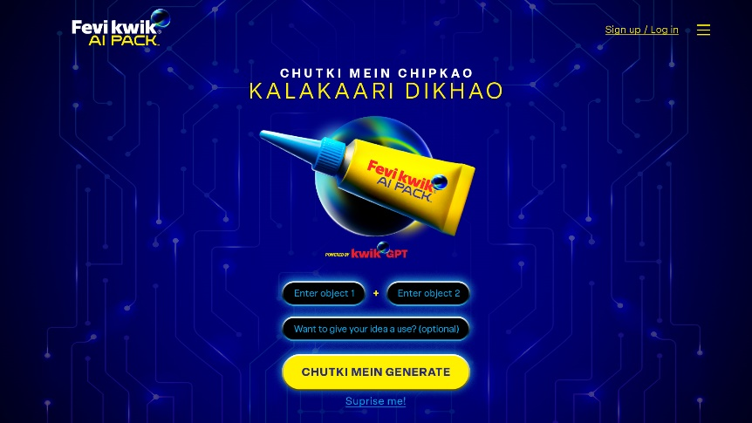

**India, 19th August, 2025:** India’s having a blast with AI—from movie scene swaps to fantasy cricket teams. Now, Fevikwik joins the fun with the Fevikwik AI Pack powered by KwikGPT, a quirky engine that fuses random objects into hilarious, unexpected innovations.

Known for fixing the broken, Fevikwik now flips the script—it's not just about repairs anymore, but also about creating the unimaginable.

Commenting on the campaign launch, **Mr. Sandeep Tanwani, Chief Marketing Officer, Pidilite Industries Ltd.,** said, *“The Fevikwik AI campaign is our endeavour to spark action through instant ingenuity and imagination, especially amongst the younger audiences. Traditionally known for quick fixes, Fevikwik is now evolving into a symbol of spontaneous ingenuity. It’s entering a broader cultural dialogue that celebrates originality, self-expression, and the joy of making things happen in the moment, all infused with the signature wit and humour that Fevikwik and Pidilite are loved for.”*

Picture this: Monsoon Beats (umbrella with headphones), Time Waist (waist belt with a watch), Cute Chops (chopping board with a vanity mirror). Fevikwik AI Pack turns these odd pairs into fun, shareable mashups, proving that with Fevikwik, it doesn’t just stick… it sparks imagination.

The campaign is crafted by creative agency Ogilvy.  Speaking about the creative direction, **Mr. Anurag Agnihotri (Chief Creative Officer) at Ogilvy India**, said, *“We live in a world where AI enables everyone to become creators overnight. With Fevikwik AI Pack, we tapped into this cultural moment to spotlight Fevikwik’s playful personality and clever utility. This is not just about a drop of glue, it is about sparking a world of possibilities. The campaign allows people to build, remix, and laugh along the way just as the brand has always done.”*

Here’s how the Fevikwik AI Pack works: Users visit the microsite [https://aipack.fevikwik.in/](https://protect.checkpoint.com/v2/r05/___https://secure-web.cisco.com/1AnzNFdiTGPGlDwgFQK70BUYRr95gqQZqwMfXcB9pZ2HP34a7IlbJ_4g1qftAaHS3aK93TdYqv79jrkOoT0Z5t0sdRbmeckWq1he9zoRHIq1xwFj2nq9znGGHc5eonOQ-SaC7mjw_mjSYrffCHIvkgwg1q-__bWUXVNAUcfJ8zpQG7XN5uB-qD-8RmHRaLia3aOWu0HOSxrK5f4o87Je2LsLdR8KtxdapSjfXfSWV-hn4bXk-sKNqxUU0UohzNRJZx7jQ_F0GgSiBfvBxYeBQTQTzzQyRDKlui4iWmTJCUfm-82GUB4biomBsdbqACllR/https%3A*2F*2Faipack.fevikwik.in*2F___.YXBzMTpwaWRpbGl0ZWluZHVzdHJpZXNsdGQ6YzpvOmY1NmQ3YjVjNzE0N2YzNGQyY2M2NjgzMzk5OTEwNTgxOjc6NzVkMjo5NTIwYWVkMzkzMDYyOGE2NzczZWFkZGJkMDhhODJjZDMzZmYwZDA1YzRhNDYxOTk0ZmU5MWNiNWQ3YmQ1YjBmOnA6VDpG), enter any two objects, and let KwikGPT work its magic. Instantly, they receive a hilarious mashup image and a quirky name for their invention. The most ingenious creations climb the leaderboard and get featured on Fevikwik’s social channels. Weekly winners take home ₹10,000, while the ultimate Chutki Mein Kalaakari Champion bags a grand prize worth ₹5 lakh. Weekly rewards will recognise the most innovative minds, with one exceptional creator ultimately crowned the champion.

The initiative comes alive through a vibrant blend of digital content, creators, and influencers across India—capturing Fevikwik’s signature wit and ingenuity.

**About Pidilite:**

Pidilite Industries Limited is a leading manufacturer of adhesives and sealants, construction chemicals, craftsmen products, DIY (Do-It-Yourself) products and polymer emulsions in India. Our portfolio also includes paint chemicals, automotive chemicals, art materials and stationery, fabric care, maintenance chemicals, industrial adhesives, industrial resins and organic pigments & preparations. Many of our products are born from strong in-house R&D. Our flagship brand **Fevicol** is a household name, synonymous with trust and reliability. Other major brands include **M-Seal, Fevikwik, Fevistik, Roff, Dr. Fixit, Araldite**, and **Fevicryl**.

**For media queries, please contact:**

**Pidilite Industries**

Hiral Jani Vasani | 9820039681 | [hiral.vasani@pidilite.com](mailto:hiral.vasani@pidilite.com)

**Adfactors PR**

Kapil Kulkarni | 98202 03787 | [Kapil.Kulkarni@adfactorspr.com](mailto:Kapil.Kulkarni@adfactorspr.com)

Sagar Singh | 87704 42068 | [sagar.singh@adfactorspr.com](mailto:sagar.singh@adfactorspr.com)