**Broken Tiles? ‘Naak Kat Gayi’ Outdoor Says It’s Time for Roff**

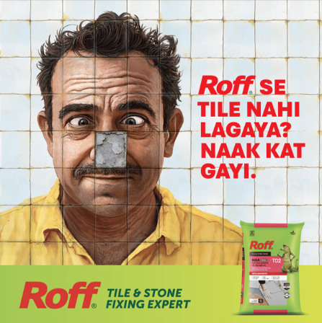

**Mumbai, August 12, 2025** – Pidilite’s tile and stone adhesive brand, Roff, has launched a humorous Out of Home campaign titled "Naak Kat Gayi." Putting a witty spin on the popular Hindi phrase, the campaign highlights the embarrassment homeowners may face due to broken or poorly fixed tiles. It’s a playful reminder to choose Roff, the expert in tile and stone fixing, and avoid sticky situations — literally and figuratively.

**Sandeep Tanwani, Chief Marketing Officer, Pidilite Industries Limited**, said, "At Pidilite, we strive to connect with our audience in a tone and language that resonates with them. Humour has always been our tonality. Roff’s new campaign is a humorous take on the importance of choosing the right tile adhesive. Usage of tiles on surfaces within homes and commercial buildings is rapidly growing. There is considerable involvement in choosing the right tiles both for aesthetics and for robustness. Through this campaign, we are reiterating that Roff continues to be the trusted Tile and stone fixing expert."

The quirky creative, can be seen across tile hubs and prominent outdoor locations in (like Bandra in Mumbai), as well as cinema halls, features a mural-style image of a man with a missing tile, right where the nose should be. The visual punchline lands with the witty caption “Roff se tile nahi lagaya? Naak Kat Gayi.”

“‘Naak Kat Gayi’ isn't just a clever play on words, it's a mirror to every homeowner's deepest fear. Because in Indian homes, when your tiles fall, so does your pride. At the heart of this insight lies Roff, a tile adhesive that does more than just hold tiles in place. It holds up your reputation. With Roff, we're not just delivering a product, we're delivering confidence, trust, and the assurance that your tiles and your honor will always remain intact. After all, our homes are extensions of who we are, and both deserve nothing less than unshakeable reliability, **says Anurag Agnihotri, Chief Creative Officer, Ogilvy India (West).**

The phrase, often used in a light-hearted way to highlight embarrassment, perfectly mirrors the consequence of using subpar tile adhesives, an embarrassing slip, quite literally. With this playful jab, Roff asserts its position as the go-to expert in tile and stone fixing, while staying true to the brand’s reputation for culturally attuned and humorous advertising.

With this campaign, Pidilite continues its tradition of delivering meaningful brand messages through culturally relevant and visually engaging storytelling, cementing Roff’s position as a market leader with a memorable creative twist.

***

**About Pidilite:**

Pidilite Industries Limited is a leading manufacturer of adhesives and sealants, construction chemicals, craftsmen products, DIY (Do-It-Yourself) products and polymer emulsions in India. Our products range also includes paint chemicals, automotive chemicals, art materials and stationery, fabric care, maintenance chemicals, industrial adhesives, industrial resins, organic pigments and preparations. Most of the products have been developed through strong in-house R&D. Our brand name, Fevicol, has become synonymous with adhesives to millions in India and is ranked amongst the most trusted brands in the country. Some of our other major brands are M-Seal, Fevikwik, Fevistik, Roff, Dr. Fixit, Araldite and Fevicryl.

For any further queries, please contact:

**Adfactors PR**

Sagar Singh | 87704 42068 | [sagar.singh@adfactorspr.com](mailto:sagar.singh@adfactorspr.com)

Kapil Kulkarni | 98202 03787 | [kapil.kulkarni@adfactorspr.com](mailto:kapil.kulkarni@adfactorspr.com)